Minutes of Meeting (MoM)
Module: 503IT – Communication and Collaboration
Project: Cyber-Smart Gaming for Education
Institution: Coventry University
Program: BSc Computing Science
Meeting Type: Intel Mission Development Review & Bug Fixes
Meeting Date: 6-8-2026
Time: 12:30 pm
Meeting Chair: Dipesh Regmi
Minute Taker: Dipesh Regmi

Meeting Purpose
- Review the current progress of the Intel Mission quiz game.
- Identify and resolve UI bugs in the question and answer layout.
- Evaluate the question bank content and answer logic.
- Review the hint system and feedback display mechanism.
- Agree on final polish items before moving to Highway Chase development.

Attendees
Members | Status
Prateek Rana | present
Prathish Thangaraj | present
Allen Twins George | present
Bishal Raut | present
Dipesh Regmi | present
Avtar | absent

Discussion Summary
- Prateek demonstrated the current state of the Intel Mission page. The question card with the floating question-mark bubble, 2×2 answer grid, and top bar HUD (chances, hint tokens, timer) were all functional.
- Bishal reported a notable layout issue: every time the player answered a question, the feedback bar appeared below the answer grid and caused the entire layout to shift downward, pushing content off-screen. This was visually jarring and disrupted the gameplay experience. Prateek investigated the issue and identified that the feedback bar was using display:none to hide itself and display:block to show itself — this caused the element to occupy no space when hidden, leading to a sudden layout reflow when revealed. Prateek suggested replacing display:none/block with visibility:hidden/visible combined with a fixed min-height, which reserves the space permanently. After implementing this fix, the layout remained stable regardless of whether feedback was showing.
- The answer button colour logic was reviewed. The team confirmed that only the selected answer button should change colour (green for correct, red for wrong), and that the overall screen flash overlay previously in place should be removed, as it distracted from the button-level feedback.
- Avtar presented the completed question bank comprising 20 unique phishing scenarios across five categories: spot the phishing attempt, URL analysis, correct response, attack classification, and security gap identification.
- Dipesh reviewed the hint system (Eliminate, Spotlight, Agent Beta) and the hint token cost model. He noted the costs were clearly communicated to the player.
- The win/lose overlay animations (star rating, confetti, level-up card) were tested and approved by the team. Minor spacing adjustments were made to the feedback bar padding.

Decisions Made
- Feedback bar will use visibility:hidden/visible with a reserved min-height — no display:none.
- Screen flash overlay removed; colour feedback restricted to answer buttons only.
- Question bank of 20 scenarios finalised and integrated into the game.
- Hint system confirmed: Eliminate, Spotlight, Agent Beta — with escalating token costs.
- Win/lose overlays approved with star rating and confetti animation.
- Timer bar will change colour: white → amber (below 55%) → red (below 25%) for urgency.

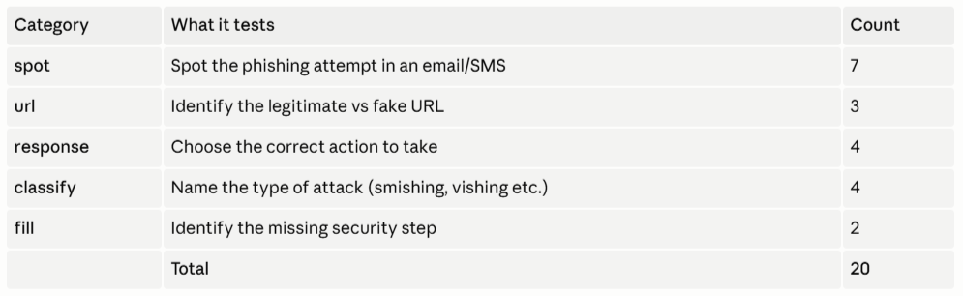
Fig: 20 scenarios covering 5 Category

Action Items
- Apply feedback bar visibility fix and test across all question types — Prateek Rana, Allen Twins George.
- Remove screen flash overlay code and verify answer-only colour feedback — Prathish Thangaraj.
- Proofread all 20 questions and explanations for accuracy — Avtar
- Test hint token deduction logic and edge cases — Dipesh Regmi.
- Begin initial layout for Highway Chase page — Bishal Raut.

Closing Remarks
The Intel Mission game is close to completion following the layout bug fix. The team acknowledged that the display:none to visibility fix was a small change with a significant UX impact. Avtar received positive feedback on the quality and variety of the question bank. The team will now shift focus to Highway Chase development.

Key Points
The following key terms and concepts should be reflected in each member's individual report:
- CSS display vs visibility — display:none removes the element from the layout flow; visibility:hidden hides it but preserves its reserved space, preventing layout shifts.
- DOM manipulation — using JavaScript to dynamically update HTML element classes, styles, and text content in response to user actions.
- User feedback design — providing immediate, clear visual responses (colour changes, animations) to help users understand the outcome of their actions.
- Question bank design — structuring diverse phishing scenarios across multiple attack types (phishing, smishing, vishing, spear phishing) to ensure broad educational coverage.
- Phishing awareness — educating users to identify deceptive emails, fake domains, and social engineering tactics used by cybercriminals.
- Hint system — a scaffolded support mechanism that gives players assistance at a cost, balancing challenge with accessibility.
- UX testing — evaluating an interface by observing real interactions to identify friction points and usability issues.

